Teaching Strategies for Chapter VIII
String Methods and the Magpie Chatbot Lab

The first half of the chapter on String methods is quite easy to teach. The AP® curriculum only requires knowledge of five String methods and they are not so bad. The only concern is with the substring method, which can be a little confusing. Consider the example below.

s1 = "aardvark";
s2 = s1.substring(j,k);

Method substring returns a set of consecutive characters from string s1, starting at index j, and ending at index k-1. That means that . . .

s3 = s1.substring(4,7);
s3 becomes "var"

Many students will think that S3 should be "vark" because they do not understand the second parameter. The 4 does mean index 4 and makes sure that students remember to start the first character at index 0. Now the second parameter 7 is not the last index. It is the upper bound of the substring and the last character is at index 6.

I use an analogy with painting a fence. Draw 7 fence pickets on the board, like the picture below and connect fence sections between the pickets. This represents a fence that needs to be painted. Now if you tell a helper to paint the sections between pickets 2 and 5 that includes 4 pickets. Yes, there may be four pickets, but only three sections that need to be painted. If students get away from using the parameters as the actual characters, but rather the boundaries of the characters, it will make more sense to them.



0 1 2 3 4 5 6

The indexOf method will be used frequently in the second part of Chapter VIII. Like the substring method, indexOf is overloaded. The indexOf method with one parameter will return the index of the first occurrence of the parameter. The second, overloaded method will return the occurrence of the first parameter after the provided index of the second parameter.

Chapter VIII shows the use of the indexOf method with this segment from program Java0806.java. The value returned for substring "is" changes as the second parameter increases.

String str = "Mississippi is a state and it is a river.";
System.out.println(str.indexOf("is"));
System.out.println(str.indexOf("is",2));
System.out.println(str.indexOf("is",10));
System.out.println(str.indexOf("is",15));

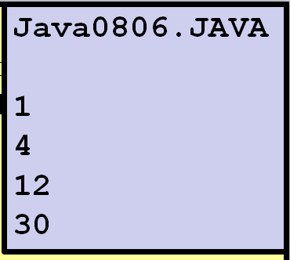

This chapter was originally taught later. It has been moved to an earlier location to allow the first AP® Lab, the Magpie Chatbot program, to be introduced earlier. If you have already looked at the Magpie Lab you might wonder what is happening when you see the programs in this chapter. It is my style to introduce concepts in separate, small focused segment. For that reason the Magpie lab is broken up into smaller versions that are introduced in a sequence. This chapter will not finish the Magpie lab. In a later arrays chapter, we will return to the lab and continue with more advanced concepts and start doing lab assignments.

